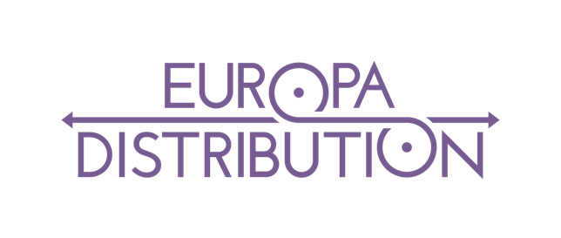
Membership Form 2026

Company: ………………………………………………………………………................………................

Address: ………………………………………………………………………....................………................

………………………………………………………………………....................................………................

Zip Code / City: …………………………………………………………………………….………................

Country: …………………………………………………………………….…....................………................

VAT or Registration number: ………………………………………………...………….……….................

Web site: …………………………………………………………………………………….………................

Legal Representative: ………………………………………………………………………………...............

Function: ………………………………………………………………………………………………...............

Email: ………………………………………………………………………………………….………................

 Office: …………………………………………………………………………………….……….................

 Mobile: …………………………………………………………………………………….………................

Other contact(s): ……………………………………………………………………………………….............

Function: …………………………………………………………………………….……….………..................

Email: …………………………………………………………………………………………………..................

 Mobile: ….………………………………………………………………………………..………..................

Membership Fee (please tick the box corresponding to your company’s situation):
❒ € 1100 per year – standard fee
❒ € 1500 per year – companies generating more than 100 000€ at the MEDIA European Film Distribution support (Results call CREA-MEDIA-2025-FILMDIST, based on admissions 2024)
❒ € 750 per year – subsidiaries of a same company present in several countries and that would normally get the standard fee

The bank references of the association will be mentioned on the invoice related to the membership fee. By his/her signature, the Member fully accepts the content of the articles of association of the AISBL Europa Distribution which are available on the website www.europa-distribution.org or requested by writing an email to communication@europa-distribution.org

Date & signature (By the Legal Representative):

